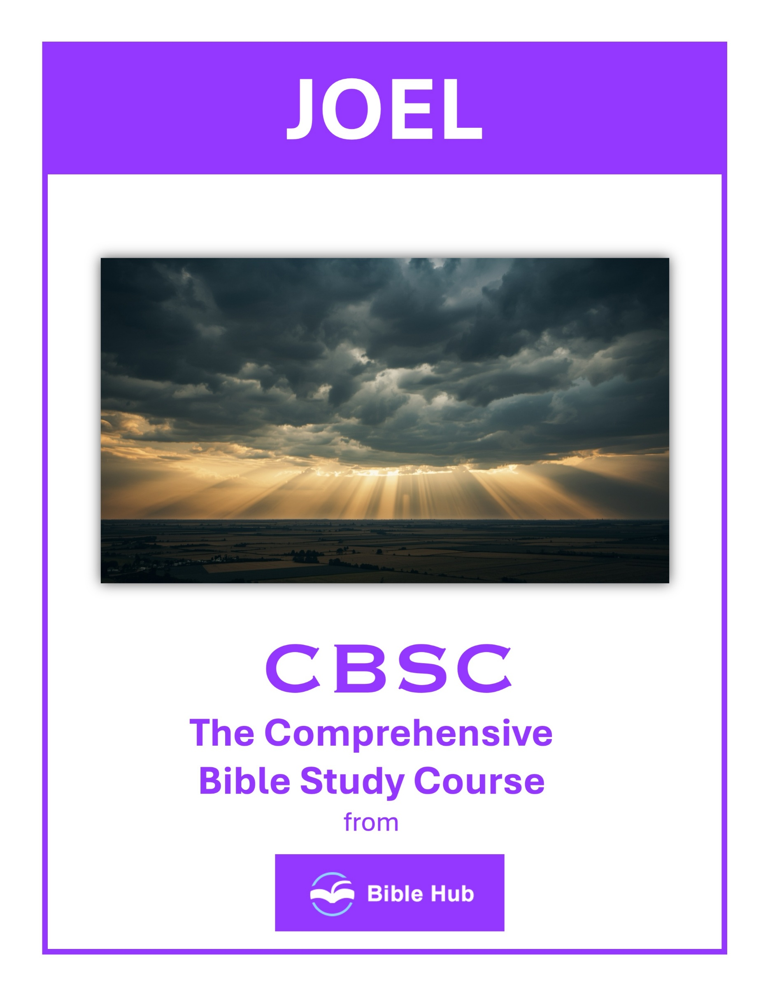

Joel 1 Teaching Points and Bible Study Questions
The Power of God's Word
The book of Joel opens with a call to hear the word of the Lord: "Hear this, you elders; listen, all who live in the land" (Joel 1:2). This reminds us of the importance of being attentive to God's voice in our lives. Just as the elders were called to listen, we too should prioritize Scripture as our ultimate guide and authority.
1. How can you apply the urgency of God's message in Joel 1 to your daily life decisions?
2. What do you hope to learn from God's warnings in Joel 1 to strengthen your faith journey?
3. Why does reflecting on the consequences in Joel 1 encourage you to prioritize God's Word in your life?
The Importance of Generational Wisdom
Joel emphasizes the need to pass down stories of God's works: "Tell it to your children, and let your children tell it to their children, and their children to the next generation" (Joel 1:3). Sharing our faith and experiences with future generations ensures that the knowledge of God’s mighty acts continues to inspire and guide.
1. How can you ensure the wisdom of past generations is preserved and shared with future generations?
2. Why do you think generational wisdom is crucial in addressing current challenges in your community?
3. What practical steps can you take to learn from the experiences of older generations?

Recognizing the Signs of the Times
The locust plague described in Joel 1 serves as a vivid reminder of the signs that God uses to capture our attention. "What the locust swarm has left, the great locusts have eaten" (Joel 1:4). We are encouraged to be observant and discerning, recognizing when God is speaking through the events around us.
1. How can you discern and respond to signs of spiritual decline in your community today?
2. What practical steps can you take to prepare for challenging times as described in Joel 1?
3. Why do you think recognizing spiritual warnings is crucial for personal and communal growth?
The Call to Repentance
Joel calls the people to lament and repent: "Put on sackcloth, you priests, and mourn; wail, you who minister before the altar" (Joel 1:13). Repentance is a powerful act of turning back to God, acknowledging our need for His grace and forgiveness.
1. How can you recognize and respond to God's call for repentance in your daily life?
2. Why do you think repentance is crucial for personal and communal restoration?
3. What steps can you take to encourage others to embrace repentance and transformation?

The Urgency of Prayer
In times of crisis, Joel urges the people to cry out to the Lord: "To You, O LORD, I call" (Joel 1:19). Prayer is our direct line to God, and in every situation, we are invited to bring our concerns and needs before Him, trusting in His provision and care.
1. How can recognizing the urgency of prayer in Joel 1 influence your daily prayer habits?
2. Why do you think immediate prayer is emphasized during crises in Joel 1, and how can this apply today?
3. What can you do to cultivate a sense of urgency in your prayer life as seen in Joel 1?
The Reality of Judgment
Joel 1 paints a sobering picture of judgment through the devastation of the land. This serves as a reminder that God is just and righteous. "The fields are ruined, the ground is dried up" (Joel 1:10). Understanding the reality of judgment encourages us to live in a way that honors God.
1. How can recognizing the reality of judgment in Joel 1 influence your daily decision-making?
2. What steps can you take to prepare for potential consequences of your actions, as seen in Joel 1?
3. Why do you think acknowledging judgment is essential for personal growth and community well-being?

The Role of the Community
The call to gather the elders and all the inhabitants of the land highlights the importance of community in seeking God: "Declare a holy fast; call a sacred assembly" (Joel 1:14). Together, we can support and encourage one another in our spiritual journeys.
1. How can our community respond collectively to crises as described in Joel 1?
2. What role does communal prayer play in addressing challenges mentioned in Joel 1?
3. Why is it important for communities to unite in times of hardship, as seen in Joel 1?
The Impact of Sin on Creation
The devastation described in Joel 1 shows how sin affects not just individuals but all of creation: "The vine is dried up and the fig tree is withered" (Joel 1:12). This reminds us of our responsibility to care for the world God has entrusted to us.
1. How can we recognize the impact of sin on our environment and take steps to restore it?
2. Why do you think sin's consequences extend to creation, and how should this influence our actions?
3. What can you do to mitigate the effects of sin on the natural world around you?

The Hope of Restoration
Even in the midst of destruction, there is a glimmer of hope. Joel's message ultimately points to God's ability to restore and renew. While Joel 1 focuses on the immediate crisis, it sets the stage for the promise of restoration found in later chapters.
1. How can you find hope in God's promise of restoration during personal times of loss or devastation?
2. What steps can you take to actively participate in the restoration process God offers?
3. Why do you think acknowledging past mistakes is crucial for experiencing true restoration and hope?
The Sovereignty of God
Throughout Joel 1, we see the sovereignty of God at work. Despite the chaos, God remains in control, orchestrating events according to His divine plan. This assurance allows us to trust in His wisdom and timing, knowing that He works all things for good.
These lessons from Joel 1 remind us of the timeless truths found in Scripture, encouraging us to live faithfully and intentionally in our walk with God.
1. How can recognizing God's sovereignty in Joel 1 influence your response to personal or communal crises today?
2. Why do you think acknowledging God's control over nature and events can impact your daily decision-making?
3. What can you learn from Joel 1 about trusting God's plan during times of uncertainty or loss?

Joel 2 Teaching Points and Bible Study Questions
The Call to Repentance
Joel 2 begins with a powerful call to repentance, urging us to turn back to God with all our hearts. The passage reminds us that true repentance is not just an outward show but a heartfelt return to the Lord. As it says, "Rend your heart and not your garments. Return to the LORD your God, for He is gracious and compassionate, slow to anger and abounding in loving devotion" (Joel 2:13). This lesson encourages us to examine our hearts and seek genuine transformation through God's grace.
1. How can you incorporate genuine repentance into your daily life and decision-making processes?
2. Why do you think God emphasizes returning with all your heart in Joel 2?
3. What steps can you take to ensure your repentance leads to lasting change?
The Day of the Lord
The chapter vividly describes the Day of the Lord, a time of both judgment and hope. It serves as a reminder that God is sovereign over all creation and that His plans will ultimately prevail. "The day of the LORD is great; it is dreadful. Who can endure it?" (Joel 2:11). This lesson calls us to live with an eternal perspective, preparing our hearts for the day when Christ will return.
1. How can you prepare spiritually for the Day of the Lord in your daily life?
2. What do you hope to change in your community before the Day of the Lord arrives?
3. Why does the call to repentance in Joel 2 matter for your personal growth today?

God's Mercy and Compassion
Despite the warnings of judgment, Joel 2 highlights God's incredible mercy and compassion. The Lord is eager to forgive and restore those who turn to Him. "Who knows? He may turn and relent and leave a blessing behind Him" (Joel 2:14). This lesson reassures us that no matter how far we have strayed, God's love is always ready to welcome us back.
1. How can you recognize and respond to God's mercy in your daily life?
2. What steps can you take to extend compassion to others as God does?
3. Why do you think God's mercy is essential for personal growth and community healing?
The Power of Prayer and Fasting
Joel 2 emphasizes the importance of prayer and fasting as powerful tools for seeking God's intervention. The people are called to gather and cry out to the Lord. "Blow the trumpet in Zion, declare a holy fast, call a sacred assembly" (Joel 2:15). This lesson encourages us to prioritize prayer and fasting in our spiritual lives, knowing that they can bring about profound change.
1. How can prayer and fasting transform your response to personal or communal crises today?
2. What do you hope to achieve through prayer and fasting in your spiritual journey?
3. Why does Joel emphasize returning to God with fasting and prayer during times of trouble?

Restoration and Renewal
God promises to restore what has been lost and bring renewal to His people. "I will repay you for the years the locusts have eaten" (Joel 2:25). This lesson offers hope that no matter the devastation we face, God can restore and renew our lives, bringing beauty from ashes.
1. How can you apply the concept of restoration in your personal relationships today?
2. What steps can you take to renew your spiritual life this week?
3. Why do you think restoration is essential for personal growth and community healing?
The Outpouring of the Holy Spirit
Joel 2 prophesies the outpouring of the Holy Spirit, a promise fulfilled at Pentecost. "And afterward, I will pour out My Spirit on all people" (Joel 2:28). This lesson reminds us of the empowering presence of the Holy Spirit in our lives, equipping us to live boldly for Christ and share His love with others.
1. How can you recognize and respond to the Holy Spirit's presence in your daily life?
2. What do you hope to achieve by embracing the Holy Spirit's guidance in your decisions?
3. Why does the promise of the Holy Spirit's outpouring inspire you to engage with your community?

The Inclusivity of God's Promise
The promise of the Holy Spirit is for everyone, regardless of age, gender, or social status. "Your sons and daughters will prophesy, your old men will dream dreams, your young men will see visions" (Joel 2:28). This lesson teaches us that God's love and gifts are available to all who call on His name, breaking down barriers and uniting us in His purpose.
1. How can you actively include others in experiencing God's promise in your community today?
2. Why do you think God's promise is extended to all people, regardless of background?
3. What can you do to ensure God's inclusive promise is reflected in your daily interactions?
The Assurance of Salvation
Joel 2 offers the assurance of salvation to those who call on the name of the Lord. "And everyone who calls on the name of the LORD will be saved" (Joel 2:32). This lesson is a powerful reminder of the simplicity and certainty of salvation through faith in Jesus Christ, encouraging us to share this good news with others.
1. How can Joel 2:32 strengthen your confidence in God's promise of salvation during difficult times?
2. What practical steps can you take to call on the Lord's name as described in Joel 2:32?
3. Why does the assurance of salvation in Joel 2 motivate you to live differently today?

The Importance of Community
The chapter underscores the importance of coming together as a community to seek God. The call to gather and pray highlights the strength found in unity. "Gather the people, consecrate the assembly; bring together the elders, gather the children" (Joel 2:16). This lesson encourages us to foster strong, supportive communities of faith where we can grow and serve together.
1. How can your community support each other during times of crisis as described in Joel 2?
2. Why do you think communal repentance is emphasized in Joel 2, and how can it be applied today?
3. What can you do to foster a spirit of unity and restoration in your community?
Living with Hope and Expectation
Finally, Joel 2 inspires us to live with hope and expectation, trusting in God's promises for the future. The chapter ends with a vision of restoration and blessing, reminding us that God's plans are good. "The LORD will be zealous for His land and will have compassion on His people" (Joel 2:18). This lesson calls us to live with anticipation, knowing that God is at work and His kingdom is advancing.
1. How can you cultivate hope in your daily life based on the promises in Joel 2?
2. What do you hope to see restored in your life, as God promises restoration in Joel 2?
3. Why does living with expectation change your perspective on current challenges, according to Joel 2?

Joel 3 Teaching Points and Bible Study Questions
The Day of the Lord is Near
Joel 3 reminds us that the Day of the Lord is approaching, a time when God will judge the nations. This is a call to be prepared and live righteously. As it says in Joel 3:14, "Multitudes, multitudes in the valley of decision! For the Day of the LORD is near in the valley of decision." This verse encourages us to make decisions that align with God's will, knowing that His return is imminent.
1. How can you prepare your heart and life for the coming Day of the Lord?
2. What do you hope to change in your community before the Day of the Lord arrives?
3. Why does anticipating the Day of the Lord influence your daily decisions and actions?
God’s Justice Will Prevail
In a world where injustice often seems to reign, Joel 3 assures us that God’s justice will ultimately prevail. "I will gather all the nations and bring them down to the Valley of Jehoshaphat. There I will enter into judgment against them" (Joel 3:2). This is a powerful reminder that God sees all and will right every wrong in His perfect timing.
1. How can you actively participate in promoting justice in your community, reflecting God's justice in Joel 3?
2. Why do you think understanding God's justice in Joel 3 is important for personal growth and decision-making?
3. What steps can you take to trust in God's justice when facing unfair situations in your life?

The Importance of Repentance
Joel 3 underscores the importance of repentance. The nations are judged for their actions, and this serves as a reminder for us to turn away from sin and seek God’s forgiveness. Repentance is not just a one-time act but a continual turning towards God, aligning our lives with His Word.
1. How can recognizing God's judgment in Joel 3 motivate you to prioritize repentance in daily life?
2. Why do you think repentance is crucial for restoring relationships with others and with God?
3. What practical steps can you take to ensure repentance leads to genuine transformation in your actions?
God’s Sovereignty Over Nations
The chapter highlights God’s sovereignty over all nations. Despite the chaos and turmoil in the world, God is in control. "The LORD will roar from Zion and raise His voice from Jerusalem; heaven and earth will tremble" (Joel 3:16). This reassures us that no matter how things appear, God’s plan is unfolding perfectly.
1. How can recognizing God's sovereignty over nations influence your perspective on current global events?
2. What steps can you take to trust God's control in international conflicts and political changes?
3. Why do you think understanding God's sovereignty is crucial for fostering peace and hope in your community?

The Promise of Restoration
Joel 3 offers a beautiful promise of restoration for God’s people. "But the LORD will be a refuge for His people, a stronghold for the people of Israel" (Joel 3:16). This is a comforting reminder that God is our refuge and strength, and He will restore and bless those who are faithful to Him.
1. How can you apply the promise of restoration in Joel 3 to your personal challenges today?
2. What do you hope to restore in your life, inspired by God's promise in Joel 3?
3. Why does the promise of restoration in Joel 3 encourage you to trust in God's future plans?
The Call to Proclaim God’s Word
The chapter encourages us to proclaim God’s Word boldly. "Proclaim this among the nations: Prepare for war! Rouse the mighty men!" (Joel 3:9). As believers, we are called to share the Gospel and prepare others for the spiritual battles they face, equipping them with the truth of Scripture.
1. How can you actively proclaim God's word in your community today, inspired by Joel 3's message?
2. Why do you think proclaiming God's word is crucial in times of conflict, as seen in Joel 3?
3. What practical steps can you take to ensure God's word is heard in your daily interactions?

The Power of God’s Presence
Joel 3 emphasizes the power of God’s presence among His people. "Then you will know that I am the LORD your God, who dwells in Zion, My holy mountain" (Joel 3:17). This is a reminder that God is not distant; He is present and active in our lives, guiding and empowering us.
1. How can you recognize and embrace God's presence in challenging situations today?
2. What do you hope to experience when you invite God's presence into your daily life?
3. Why does acknowledging God's presence empower you to face personal battles with confidence?
The Blessing of Abundance
The chapter speaks of the abundance that comes from God’s blessing. "In that day the mountains will drip with sweet wine, and the hills will flow with milk" (Joel 3:18). This imagery of abundance is a reminder of the spiritual blessings we receive when we walk in obedience to God.
1. How can you recognize and share the blessings of abundance in your community today?
2. Why do you think abundance is linked to justice and restoration in Joel 3?
3. What can you do to cultivate a mindset of abundance rather than scarcity in your daily life?

The Assurance of God’s Protection
Joel 3 assures us of God’s protection. "Judah will be inhabited forever and Jerusalem from generation to generation" (Joel 3:20). This promise of protection extends to us today, as God watches over His people and ensures their ultimate safety and security.
1. How can you find assurance in God's protection during challenging times in your life today?
2. Why do you think God's promise of protection is important for your faith journey?
3. What practical steps can you take to trust in God's protection daily?
The Eternal Nature of God’s Kingdom
Finally, Joel 3 points to the eternal nature of God’s kingdom. "For the LORD dwells in Zion" (Joel 3:21). This is a powerful reminder that God’s kingdom is everlasting, and as believers, we are part of this eternal kingdom, called to live with an eternal perspective, focusing on what truly matters.
1. How can you actively participate in building God's eternal kingdom in your daily life?
2. Why do you think God's eternal kingdom offers hope in times of personal or global crisis?
3. What practical steps can you take to align your priorities with the values of God's eternal kingdom?

